SECTION A
Answer all parts of question 1 (50 marks in total).
1. (a) Suppose that x₁ = 3, x₂ = 9, x₃ = 16, and y₁ =2, y₂ = 1, y₃ = 0.5.
Calculate the following quantities:
i. 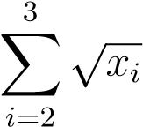 ii. 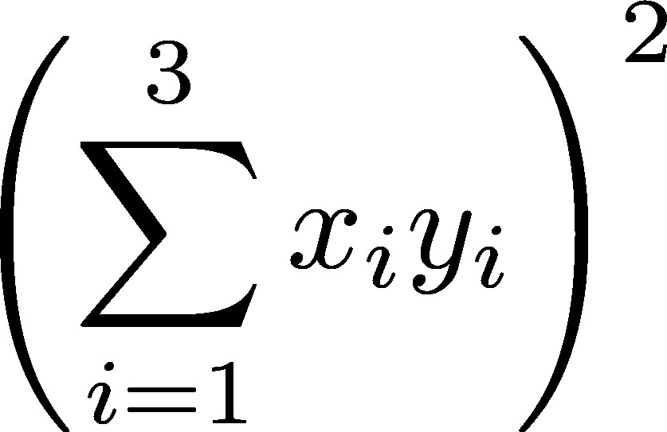 iii. 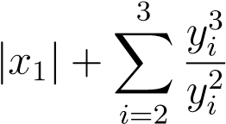.
3
X
i
=1
x
i
y
i
!
2
i. $\sqrt{(9+16}$
= 5
ii. [(-3 + 9 + 16) x (-2 + 1 + 0.5)]²
= 121
iii. 3 + $\frac{{\left(1+0.5\right)}^{3}}{{\left(1+0.5\right)}^{2}}$
= 4.5
(6 marks)
(b) Classify each one of the following variables as either measurable
(continuous) or categorical. If a variable is categorical, further classify it as either nominal or ordinal. Justify your answer. (No marks will be awarded without a justification.)
    - Age brackets of 18–30, 31–50, 51–70, 70+
Age bracket is categorical because it assigns an individual’s age a specific category. The variable is also ordinal because the age bracket categories can be classified in an increasing or decreasing order.
    - Passport number
Passport number is continuous because it could have an infinite number of values between 0 and 9.
    - A country’s inflation rate:
The inflation rate is continuous because the percentage can take on any value along the continuum from zero to 100%.
(6 marks)
(c) State whether the following statements are true or false, and provide a brief explanation. (No marks will be awarded for a simple true/false answer.)
    - For a set of observations x₁,x₂,...,x_{n}, with mean ¯x, then:
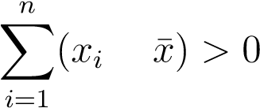.
This is false
$\sum_{i=1}^{n}{\left(xi- \bar{x}\right)= }\sum_{i=1}^{n}{xi}$ - $\sum_{i=1}^{n}{x̄}$
$\sum_{i=1}^{n}{\left(xi- \bar{x}\right)= }$ nxi - nx̄
$Therefore, \sum_{i=1}^{n}{\left(xi- \bar{x}\right)= }$0
    - For two independent events A and B such that P(A) > 0 and P(B) > 0, then:
P(A [ B) < P(A) + P(B).
Therefore, P(A ∩ B) = 0
So the given statement is true
    - For a random variable X, E(X²) can be less than (E(X))².
Var (x) = E (X²) – [E (X)]²
So, Var (x) ≥ 0
Therefore, E (X²) cannot be greater than [E (X)]²
The statement is false.
    - Rejecting a true null hypothesis is known as the power of a test.
The failure to reject a false null hypothesis is type II error and the power of test is the probability of correctly rejecting a false null hypothesis.
The statement given is false.
v. A 4-by-2 contingency table which results in a X² test statistic value of
6.724 is statistically significant at the 5% significance level.
A 4 by 2 contingency table will give a much higher X² value, which may not be significant at 5% significant level.
The statement is false. (10 marks)
(d) X is a normal random variable with a mean of µ = 5. If P(X < 1) = 0.20, approximately what is the value of the variance, ²?
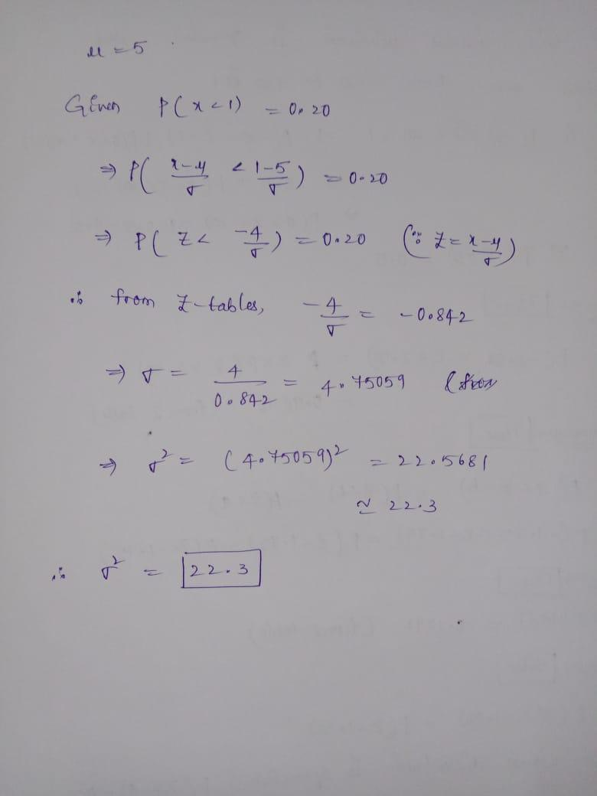
(5 marks)
(e) The probability distribution of a random variable X is given below.
X = x | -2 | -1 | 0 | 1 | 2
P(X = x) | k | 2k | 4k | 2k | k
- Explain why k = 0.10.
When the probability of all of them are added, they must add upto one
Therefore, k + 2k + 4k + 2k + k = 1
10k = 1, k = 0.1

(2 marks)
ii. Given that E(X) = 0, calculate the standard deviation of X to four decimal places.
(-2 x 0.1) + (-1 x 0.2) + (0 x 0.4) + (1 x 0.2) + (2 x 0.1)
= -0.2 + -0.2 + 0 + 0.2 + 0.2
= 0
Standard deviation = $\sqrt{0}$
= 0

(3 marks)
- Is it possible to calculate E(1/X)? If yes, calculate its value. If no, explain why.
No, it is not possible because E(x) is zero and 1/0 cannot be calculated
(3 marks)
- Does X have a normal distribution? Briefly explain your answer.
Yes, the standard deviation is zero and this indicates that X tend to be close to the mean.(2 marks)
(f) Based on the central limit theorem, you are told that a 90% confidence interval for a population proportion is (0.7077,0.7723).
- What was the sample proportion which resulted in this confidence interval?
Lower limit = 0.7077
Upper limit = 0.7723
P = lower limit + upper limit / 2
= (0.7077 + 0.7723)/ 2 = 0.74
P = 0.74
- What was the size of the sample used?
Margin of error = 0.7723 – 0.7077 / 2 = 0.0323
N = ($\frac{z value }{margin of error}$)² x p x (1-p)
Z value = 1.645
= ($\frac{1.645}{0.0323}$)² x 0.74 x (0.26)
= 499
(g) It is assumed that investors are equally split between those who prefer ‘growth’ stocks and those who prefer ‘value’ stocks. In a random sample of 200 investors, 105 agreed with the statement ‘Growth stocks are better than value stocks’.
- Conduct a two-sided hypothesis test, at the 5% significance level, to test whether in the population of investors there are equal preferences for growth and value stocks. Show all steps of your calculation and use the ‘critical value’ approach to perform the test.
H0: p = 0.50
Ha: p ≠ 0.50
Significance level = 0.10
Test statistic = z test
Critical z value = 1.645
Calculating sample statistic:
Proportion of people that agreed (p) = 105/200 = 0.53
q = 1 – 0.53 = 0.47
Calculating the statistic,
= (0.53 – 0.50) $\sqrt{\frac{0.5*0.5}{200}}$ = 0.71
The critical z value (1.645) is greater than the calculated value (0.71) hence we fail to reject the null hypothesis

(5 marks)
- Calculate the p-value of the test statistic value calculated in part i.
P (z = 0.71) is calculated as:
0.50 (0.71) = 0.355
= 0.355

(2 marks)

